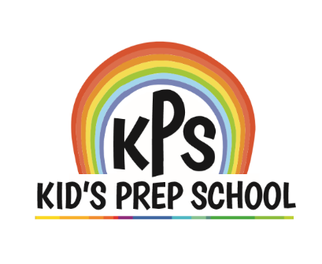

KPS NEWS

[](http://www.google.com/url?sa=i&rct=j&q=&esrc=s&source=images&cd=&cad=rja&uact=8&ved=0CAcQjRxqFQoTCKLBgO7LxccCFcInHgodqbsJMg&url=http://www.clipartpanda.com/categories/apple-clipart-black-and-white&ei=yhXdVaK0GsLPeKn3ppAD&psig=AFQjCNFoQ1PwByVyIl6wO-xLgw8JUOnIVg&ust=1440638769766886)

SEPTEMBER 2023

**Nationally Accredited**

|  |  |
| --- | --- |
| **Monday, September 4th** | **Labor Day Holiday**  **School Closed** |
| **Friday, September 8th** | **Breakfast with our grandparents**  **7:30 – 8:30 am** |
| **Wednesday and Thursday, September 13th**  **and 14th** | **Photo Days** |
| **Thursday, October 5th** | **Open House /**  **Curriculum Night**  **6:00 pm** |

**Dear Families:**

Our new school year is off to a great start! Daily routines have already been developed, which helps children know what to expect and to look forward to. You will get the feel of a typical day with us when you attend our Open House / Curriculum Night on Thursday, October 5th , at 6:00 pm. This is an excellent opportunity for families to meet each other.

We are enjoying getting to know each of you as you enter and leave the building. We will warmly welcome you when you have questions, compliments or concerns you would like to discuss with us.

Remember to contact us on info@kpschildcare.com and like us on Facebook, to view some very cute photos .

Have a great new school year.

The Administration Team

**OPEN HOUSE AND PARENT – TEACHER CONFERENCES:**

**What is the difference?**

Every year, we will have an Open House / Curriculum Night in the Fall and schedule parent – teacher conferences in October/November. Many parents often make the mistake of thinking that these terms are interchangeable, but they are not. These are two very distinctive meetings that are held for very different reasons.

At our Open House / Curriculum Night, you will meet our teachers and other staff members. You will see samples of our curriculum on display. Teachers will tell you about our daily schedule. Extracurricular activities will be highlighted. Children will proudly escort you around the classroom where they will show you some recent work they have accomplished.

Please understand that this is not a time to discuss your child’s performance with the teacher. Parent – teacher conferences are scheduled for October/November. At that time, you will be able to confer with your child’s teacher in more detail.

We hope you can attend both of these events!